Greetings, we are a group of university students doing a survey on the ZARA website. The survey is for you to give your opinions on the changes about designs and interfaces we would like to bring to the website.

Age:

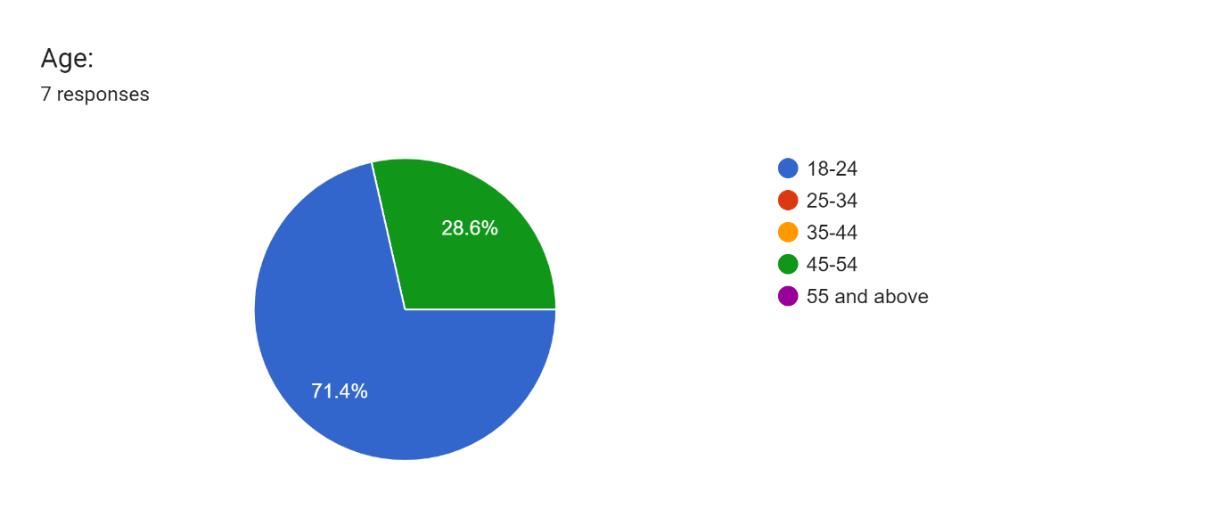

1. Users need to choose country and language before accessing the homepage.

2. Homepage takes too much time to load.

3. ZARA logo is too huge and overlaps the page content.

4. All texts are in upper-case and low contrast colours small fonts.

5. Navigation menu is hidden behind a hamburger button and not categorised.

6. Poor colour contrast of elements across the website.

7. The slider on the product page doesn’t indicate what it is used for; confusing and not helpful.

8. Navigation bar on bottom of the homepage doesn’t work. Instead, it changes the slides of images and sometimes get lost with bad contrast colour of images.

9. Large images with small texts and many white spaces on product page.

10. Same products are shown multiple times.

11. Search bar is randomly place on the right side, floating kind of in mid-air; not noticeable.

12. If a product is “New” or a “Best Seller”, the coloring should be bright rather than black.

13. No channel for customer feedback.

14. User must scroll horizontally to see cart.

15. During checkout items bought are not displayed and prices are barely visible.

16. Filters menu and customer service are not as easy to identify.

17. Chat box not responsive

18. Newsletter page uses too much of white space.

19. ZARA should have ability to change the currency.

20. Have you ever encountered an issue while shopping on the ZARA website?

If yes, please specify

The sizes are not there

